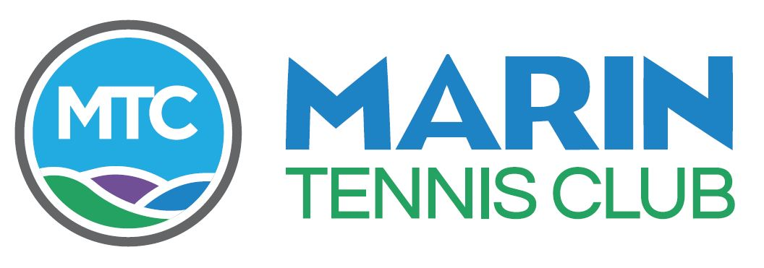
MARIN TENNIS CLUB
ANNUAL MEETING
February 27, 2020 - 6:00PM

AGENDA

- Establish Quorum Eduardo Madueno Acting Secretary
- Welcome and President’s Report Mark Clem President
- Committee Reports
- House and Grounds Jason Holmes/Marty Marks Chair
- Tennis Jeff Birkenseer Chair
- Membership Mick Spilsbury Chair
- Social Tennis/Entertainment Rob Lang Chair
- Finance Stuart Keirle Chair,
- Open Forum Mark Clem/Aric Clark
- Acknowledgement of Outgoing Directors Mark Clem/Eduardo Madueno
- Volunteer Service Award Mark Clem/Chris Horne
- Election of New Directors
The following Voting Members have been nominated by a duly appointed
Nominating Committee to serve terms on the Board of Directors as noted below

JEFF BIRKENSEER 2020 – 2023 – 3 YEAR
ANGIE DANIELSON 2020 – 2023 – 3 YEAR
LINDA GORDON 2020 – 2023 – 3 YEAR
LIZ COLLINS 2020 – 2022 – 2 YEAR
MAUREEN TIERNEY 2020 – 2021 – 1 YEAR

.
- Adjournment – COMPLIMENTARY DINNER AND NO HOST BAR
.
ORGANIZATION MEETING OF THE NEW BOARD OF DIRECTORS FOLLOWS UPSTAIRS

