September 14, 2020

Marin Tennis Club
925 Belle Ave.
San Rafael, CA 94901
Ph: 415-457-5160
Email: manager@marintennisclub.com

RE: Marin Tennis Club (WomensSpa), 925 Belle Ave. San Rafael, CA 94901,
Bldg. Permit # B23503

Dear Owner:

Plans are APPROVED for the above referenced address with the following conditions:
- Provide a detail showing dimensions of spa stairs dept (T-1, T-2) as shown in the Pool Code diagram below, along with dimensions of the stair railing, including the dimension between each step and the rail (H-2, T-3)
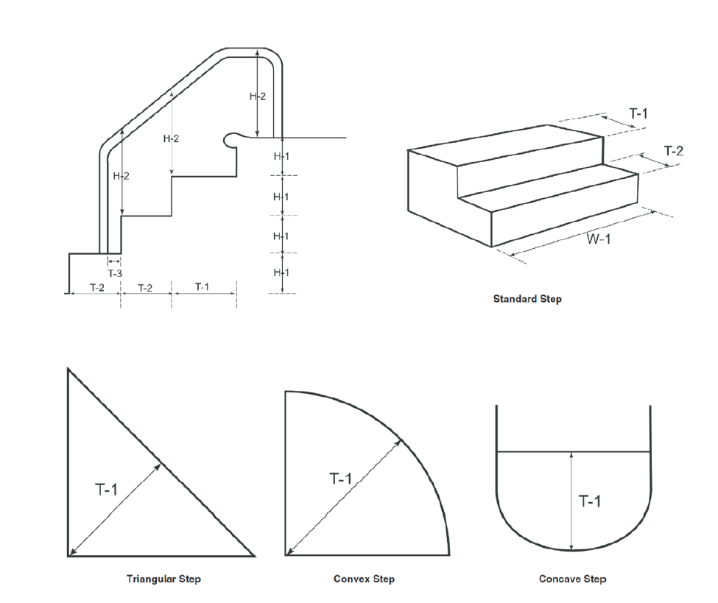
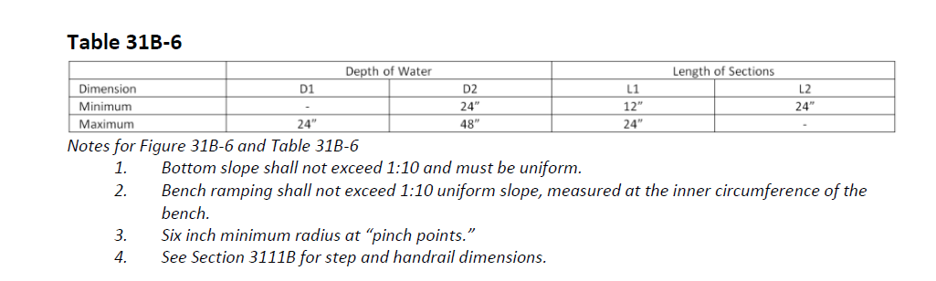
- Include a note on plans that the spa aeration system (jets) is separate from the recirculation system.

- Obtain local Building Department and all applicable agency permits and approvals prior to construction and operating pool. Check with the Building Department to see how many sets of plans they require to be stamped approved.
- Provide updated California Department of Public Health (CDPH) AB1020 form to Environmental Health prior to the final inspection.
- Environmental Health and Safety stamped plans shall be maintained at the jobsite when constructing.
- All suction outlets shall be equipped with suction fittings that meet the ANSI/APSP-16 2011 performance standard.
- The lifespan for the AquastarA10RCFRxxx suction covers at this spa is 5 years. Once expired, covers must be replaced with approval from EHS.
- The pool owner, operator or designated agent shall notify EHS prior to scheduling the following inspections:
  - Exposed plumbing; and
  - Prior to applying pneumatically placed concrete; and
  - Prior to applying the final surface to the pool shell; and
  - At the completion of construction.
- At the final pool inspection, proper pool enclosure, water chemistry, and turnover shall be provided in accordance with all applicable codes.
Contact our office at least five working days in advance to schedule inspections.
Be advised that plans expire and become null and void if the work authorized by approval of the plans is not completed and inspected within two (2) years from the date of the plan approval.

Any changes made to the approved plans must be reviewed and approved by EHS and may be subject to plan review fees, based on the extent of the changes.
Written approval by EHS is required prior to opening a pool to the public. I may be reached with any questions at (415)-473-7521 or via email at LNward@marincounty.org.

Sincerely,

Loni Ward, REHS
Senior Environmental Health Specialist
Environmental Health Services

CC: Diamond Pools & Spas Inc. 7361 Wagon Wheel Lane Vacaville, CA 95688
chris@diamondpools.org
Don Jeppson, Chief Building Official, City of San Rafael
Katie Dea, EHS, Environmental Health Services

