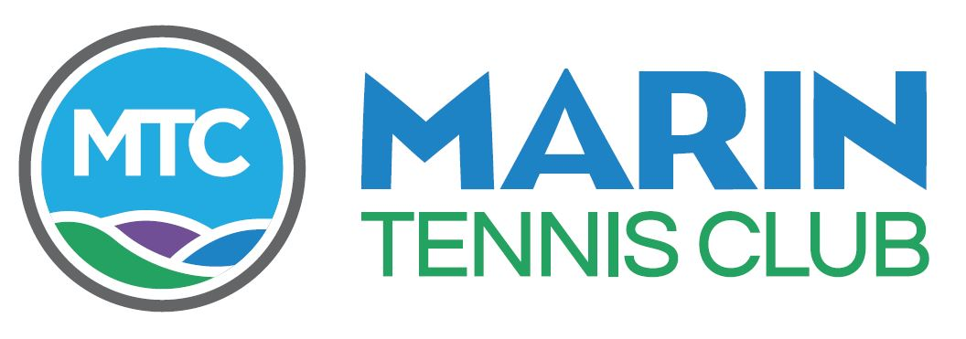
MARIN TENNIS CLUB
ANNUAL MEETING
February 28, 2019 - 6:00PM

AGENDA

- Establish Quorum Emily Birkenseer Secretary
- Welcome and President’s Report Rich Hoffman President
Liz Collins Vice President
- Committee Reports
- House and Grounds Jason Holmes Chair
- Tennis Jeff Birkenseer Chair
- Membership Emily Birkenseer
- Social Tennis Herb Gottlieb Chair
- Entertainment Janet Bosnich Chair
- Finance Stuart Keirle Chair, John Honey Treasurer
- General Manager’s Report Chris Horne
- Open Forum Rich Hoffman, John Honey, Chris Horne
- Acknowledgement of Outgoing Directors Rich Hoffman Emily Birkenseer
- Election of New Directors
The following Voting Members have been nominated by a duly appointed
Nominating Committee to serve terms on the Board of Directors as noted below

EDUARDO MADUENO 2019 – 2022 – 3 YEAR
CARNET WILLIAMS 2019 – 2022 – 3 YEAR
JANE DUDLEY 2019 – 2022 – 3 YEAR

.
- Adjournment – COMPLIMENTARY DINNER AND NO HOST BAR
.
ORGANIZATION MEETING OF THE NEW BOARD OF DIRECTORS FOLLOWS UPSTAIRS

