Thanks for your thoughtful response.

Agree that we should break this up into 2 parts:  1) ideal BOD composition 2) directions to nominating committee.

Determination of ideal composition is # 1 priority for Sept meeting.

**Gender:**  I hope we all agree that this is the 1st priority and easiest to define.  We should always have at least 4 women & 4 men.  If we cannot agree on level & age at Sept meeting. I would still like to get this one approved.

**Levels**:  Agree that we should always have 1 person at each level.  Jacquie also suggested that we should we have someone that does not play USTA.  But given that 72% of members are 3.5 or 4.0, I would not want to overweight 3.0 or 4.5. Our distribution of member’s ratings is almost a standard distribution (bell curve) and I would guess that this maps directly to USTA national rating distribution.  Thus this means that the majority (68-72%) of our members will always be 3.5’s or 4.0’s.  BOD should reflect this.

**Age:** From our member DB, age is the least reliable measure.  This is because we have a number of members that refuse to provide their birthday.  This is why we use USTA age groups.  I initially extracted this info from USTA about 4 yrs ago.  For individuals not playing USTA, I estimated their age group.  New member info is populated correctly. But there has been no update since my initial creation, so I would assume that our population is actually older that than the numbers I distributed.   I agree that we should try for representation at each level, but this also need to make sure we are weighted higher toward the older end 55+.  I will try to see if we can get more info from USTA.  But for now we may want to defer using this criteria?

**Nominating Committee Instructions**

I love using point scales to help determine best candidates.  But we need to remember that when we give instructions to the Nominating committee, we already have a starting point of the remaining BOD directors.  So we are looking for specific types of folks to ensure that the next BOD meets our ideal goals.

For example, next year we need to replace 4 BOD directors (normally only 3).  2 of the expiring directors are women and only 1 will remain on BOD.    If we want to achieve the ideal mix of at least 4 women & 4 men next year, nominating committee will need to find 3 women and 1 man.

Aric

On Wednesday, September 18, 2019, 12:00:17 PM PDT, carnet <[carnet@gmail.com](mailto:carnet@gmail.com)> wrote:



Hi,

Aric thanks for sending these along. My comments:

1) I think for age goals I would suggest we have a diversity goal to have the following

- 1 Dir under 45

- 1 Dir 45-55

- 1 Dir 55-65

- 1 Dir 65+

I believe this better represents the needs of differing age groups within the club. This might not be a 1:1 relationship with the population within these age brackets, but it does make sure we have a broad set of viewpoints based on age.

2) As for playing levels I would suggest we am for 1 director at each of the major levels. 3, 3.5, 4.0 and 4.5 to again represent a diverse set of needs and viewpoints.  This is not too different from your message, but just making it even clearer our goals.

As the nominating committee puts together their list of candidates they can give a point to each of the criteria and aim to put forward a list of people that get all three points (plus they would make good directors generally). E.g 1 point for filling an age bracket, 1 point for filling a playing level bracket, and 1 point for filling our gender bracket.

aloha,

c

On Wed, Sep 18, 2019 at 9:45 AM, Aric Clark <[tunik23@yahoo.com](mailto:tunik23@yahoo.com)> wrote:

At our last meeting we agreed to discuss and hopefully pass a resolution in  Sept for ideal composition of BOD Directors so we can give instructions to 2020 Nominating Committee.

Ideally the composition of BOD should reflect membership demographics.  Three primary factors I see for consideration:   Gender, Age, playing level.  Including all 3 factors may be too complex implement, but think it would still be good to have as goal or guideline.  We should give priority to each category.   I would suggest: #1 gender; #2 Age;  #3 Playing level

Comments & Suggestions Please!

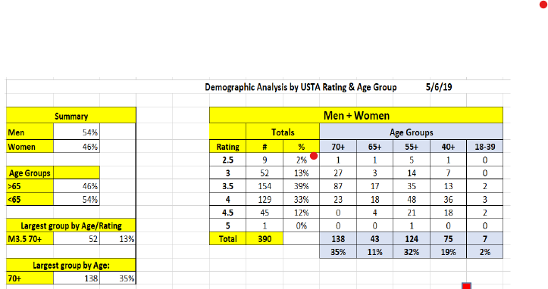

**Possible Goals based on 2019 demographics:**

**Gender:**

**Recommended goal:   4 men & 4 women**

**Age:**

**Recommended goal:   4 Directors  65+**

**Playing Level:**

**Recommended goal:   2-3 Directors at 3.5 and 4.0 level;  1 at 3.0 & 4.5 level.**