Recommend the creation of a subcommittee to make a recommendation on revised contract, including Clinics with rent reduction method at October meeting. Committee should be composed of Chris (as acting Tennis Director, Jacquie as former Liaison and at least 2 other Directors).

Overview:
- Rental Income is much improved over arrangement with Devon
  - Total Annual Income: $25,427
  - Monthly Average: $2,119
  - Net Improvement over Devon: $15,688

- Clinics: The primary Pro’s ( Dave, Wakana & Geoff) have provided 12 clinics April- Sept and are scheduled for more in October & November.
  - Clinics have been very well received by members.
  - The Sept Clinics have been sold out with waiting list.
- In May and June Clinics were scheduled, but unable to occur due to scheduling issues. Rent caps were in effect, so Pro’s got benefit of cap without providing a clinic. This was a mistake and should not reoccur.
  - Different rent reduction methods were used:
    - Dave & Geoff had $500 rent cap
    - Wakana rent was reduced to $10 p/hr, and no fixed $ cap
- Rent loss adjusted for value of clinics was $2,774 or $229 p/mo over entire year.

- Rental contract is up for renewal in October.
- All new terms for Clinics need to take into consideration that Pro’s are NOT employees and will only under take Clinics if they in their best financial interest. We do not want to activate the CA-5 bill that would make them employees.
- New contract should include:
  - Regular monthly or seasonal Clinics using a specific rent reduction method
  - Reduction in rent only is only granted in month clinic is given
  - Same rent reduction method should be used by all Primary Pro
    - We do NOT want to have to take Pro’s on as employees and make back payments. Method must not result in the creation of a 1099.
    - May need an alternative method for non-primary Pro’s
  - Possible methods of rent reduction:
    - Monthly Fee Cap (if used, amount TBD, but should probably be greater than $500, [perhaps $750])
    - Reduction of Hourly fee (if used, amount TBD, but should probably be greater than $10 [perhaps $12.5])
      - We used this method with Wakana and it appears to have increased revenue over the fixed Cap used for Dave & Geoff. Looks like it is WAY better than a fixed cap of $500 during high volume summer months. Or we could increase the Cap to perhaps $750.
        - This might change during the lower volume winter months that are subject to rain and smoke.
    - Credit method appears to be undesirable due to legal consequences

Rental Agreement is included on last page:
Details:
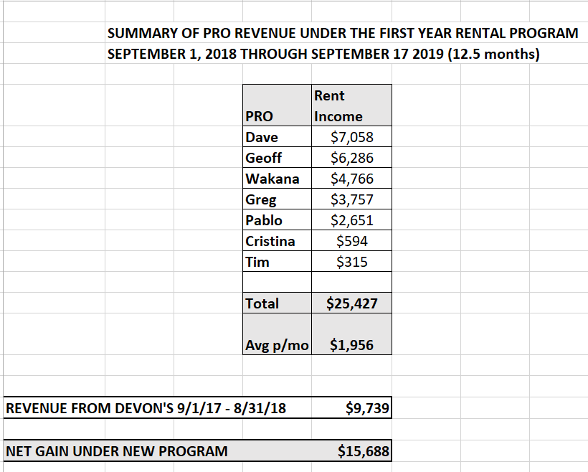

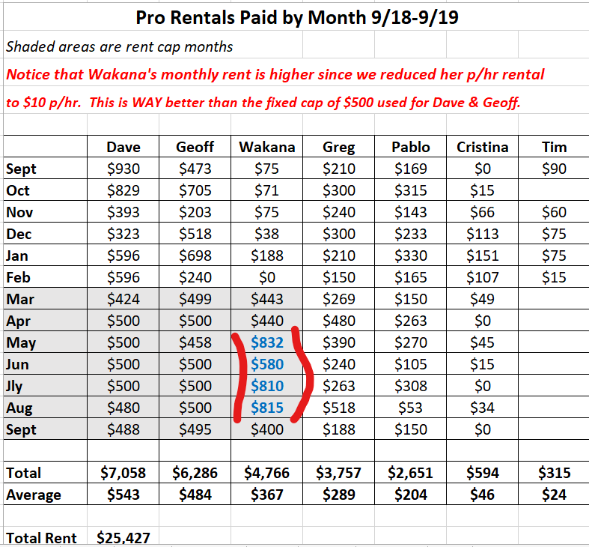

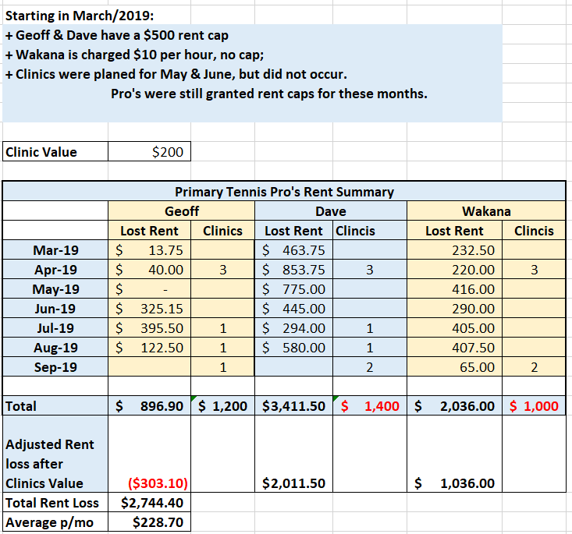

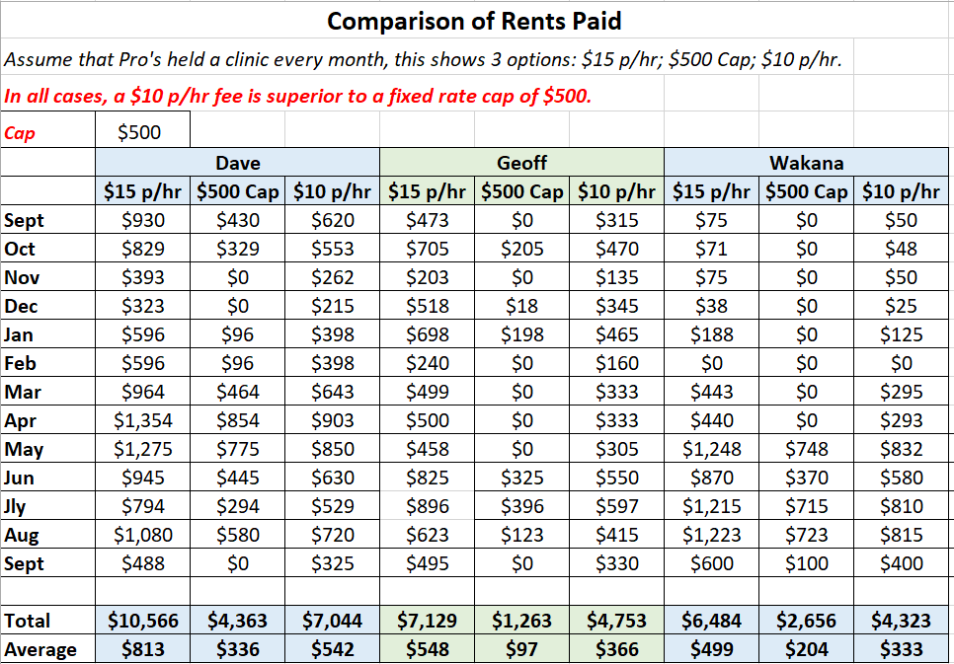

MARIN TENNIS CLUB
925 Belle Ave., San Rafael, Ca. 94901
Phone: 415-457-5160; Email: manager@marintennisclub.com
MARIN TENNIS CLUB TENNIS COURT RENTAL AGREEMENT

PRO’S NAME________________________________________________________________
ADDRESS: __________________________________________________________________
PHONE: (cell)____________________________
EMAIL: _________________________________
AGREEMENT TERM: The effective date of this agreement is OCTOBER 1, 2018. This agreement may be terminated by either party, with or without cause, at any time, subject to giving five days written notice to the other party.
COURT RENTAL FEES: $15 PER HOUR/$7.50 PER HALF HOUR
CONDITIONS OF USE:
- PRO will be invoiced weekly on Thursday with payment due on Friday
- PRO will be responsible for the collection of all lesson fees including MTC members. MTC will not be providing billing service to the Pros.
- All nonmembers will be required to sign a liability waiver prior to taking the lesson. Waivers will be available in a binder in the tennis office.
- PRO will provide MTC a certificate of insurance indemnifying MTC.
- PRO will not be able to sublet the courts.
- Use of the tennis courts will be limited to tennis instruction only.
- PRO will be required to login all lessons on the court chart at the front desk legibly, so the office manager can determine who is using the courts and keep record of court time used.
- Tennis courts reserved and not cancelled will be billed to the PRO.
- All teaching equipment, including balls, will be provided by PRO. MTC will provide the tennis office for storing equipment and balls onsite.
Furthermore, PRO agrees to indemnify, defend, and hold harmless the Marin Tennis Club, its officers, members, employees, agents and licensees from all claims, demands, losses, lawsuits or legal liability for injuries to persons, including death, or damage to property, or negligent conduct arising out of or in any way connected with the use of premises rented herein or the activity for which this agreement issued.
PRO’s Signature _______________________________________ Date ______________________
MTC General Manager Signature ___________________________________ Date ____________
Print Name ___________________________________

