Blasts From the GM’s Desk……………………..

TENNIS SHORTS:
- “September Evening Clinic Series: FOCUS IS COMBO ROUND ROBIN WITH PRO COACHING” In a cooperative effort with your MTC Board and our MTC Teaching staff there will be a series of Clinics in September that will focus on strategy for playing successful COMBO level tennis. The USTA COMBO season starts in September so perfect timing to work on your game. The format for the clinic: Players sign-up with a COMBO Partner who they play with in the round robin. The Pros will provide on court coaching during the games. Clinics will start at 6pm till 7:30pm. Show up early to warm-up: CLINIC DATES AND LEVELS: Thursday September 12th Level 7.5 Men/ Women with Coach Dave and Coach Wakana, Friday September 20th Level 6.5 Men/Women with Coach Geoff, Thursday September 26th Level 8.5 Men/Women with Coach Dave and Coach Wakana. You can sign up by calling the main office, email Elmira at office@marintennisclub.com or on the sign-up sheets at the front desk. Clinics are limited to the first 20 players to sign up and they are complimentary. Look for future announcements for clinics in October and November!
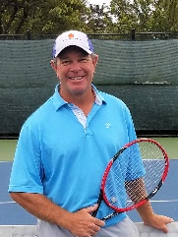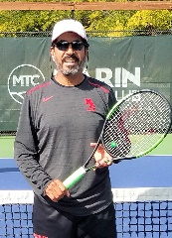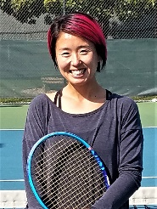
- HERB’S HIT AND RUN LABOR SPECIAL! This weekend Herb’s popular Hit and Run program will be held at its normal time on Saturday at 10:30 to 12:30 but we have a Labor Day Special with an extra Hit and Run Session at the same time, 10:30 to 12:30. Come out, hit a lot of balls and meet some new hitting partners!
- MTC COED OPEN SINGLES CHAMPIONSHIP TOURNAMENT: MTC will be hosting a new event in October to determine who is the Overall MTC Singles Champion, Gentleman or Lady. Entry forms will be available at the office starting September 1st and close September 25th. The seeding committee will determine the top 8 players who enter and place them in the main draw of 16 with a bye. The main draw will be played on the weekend of October 26th and 27th. All other entrants will be placed in a qualifying tournament that starts October 1st. Players will be responsible to set up their own matches each week. Winners will advance to play the next round. The final 8 players in the qualifying tournament will fill the byes in the main draw and will play on the tournament weekend. The round of 16 and quarters will be played on Saturday followed by the semis and finals on Sunday. There is no charge for the tournament and no limit on the entries. WHO IS THE BEST AT MTC!!!!!!!
- REMINDER “COURTS WILL BE WASHED NEXT WEEK”

GENERAL NEWS ITEMS:
- COMMUNICATION THROUGH TEXTS: Club Automation, our Club Software Program, now offers clubs the ability to send text messages to their members. We have added this as a feature to our program. I will use text messaging for quick reminders, important club announcements that need immediate communication and links to flyers and newsletters. Many of the club emails are not read which result in important announcements being missed. This feature will be up and running in a couple of weeks.
- YOUR HOUSE AND GROUNDS IN ACTION: Big Kudos to Lisa Cush and the House and Grounds committee for replacing our old cushions and umbrella covers on the front deck with brand new Wimbledon Green cushions and Umbrellas. Check out the picture below if you haven’t seen them yet. They are so comfortable too!
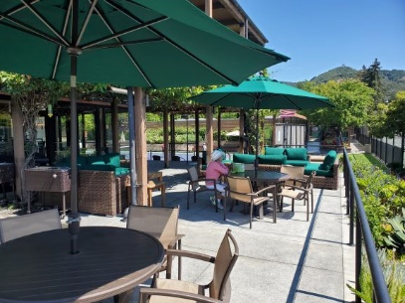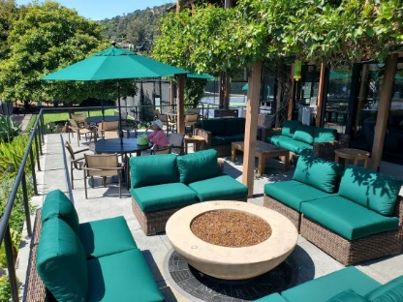
- JOIN US FOR A WINE DROP SOIREE FOR A GREAT CAUSE: MTC member Paige Hirschkop is one of the main organizers for Marin Charitable’s 57th Annual Fall Fundraiser which will take place at Sweetwater Music Hall in Mill Valley on October 26th. Marin Charitable provide grants to over 50 nonprofit organizations who are helping improve the lives of youth in Marin County. As part of this year’s Fundraiser, the Foundation will be presenting a Mystery Wine Grab where bottles of wine will be auctioned off at the event. On Thursday October 3rd from 7pm to 9pm, MTC and the Hirschkops will host a Wine Drop Soire social where your entry fee is a donation of 2 bottles of wine valued at $20 per bottle that will go towards the auction event. There will be a no host bar and finger food available during the Soire. More info and details to follow but mark your calendars! Sign up at the front desk please!

